Ideation Phase

Define the Problem Statements

|  |  |
| --- | --- |
| Date | 17 September 2022 |
| Team ID | PNT2022TMID31883 |
| Project Name | Project - Smart Waste Management System For  Metropolitan Cities |
| Maximum Marks | 2 Marks |

# Customer Problem Statement Template:

Create a problem statement to understand your customer's point of view. The Customer Problem Statement template helps you focus on what matters to create experiences people will love.

A well-articulated customer problem statement allows you and your team to find the ideal solution for the challenges your customers face. Throughout the process, you’ll also be able to empathize with your customers, which helps you better understand how they perceive your product or service.

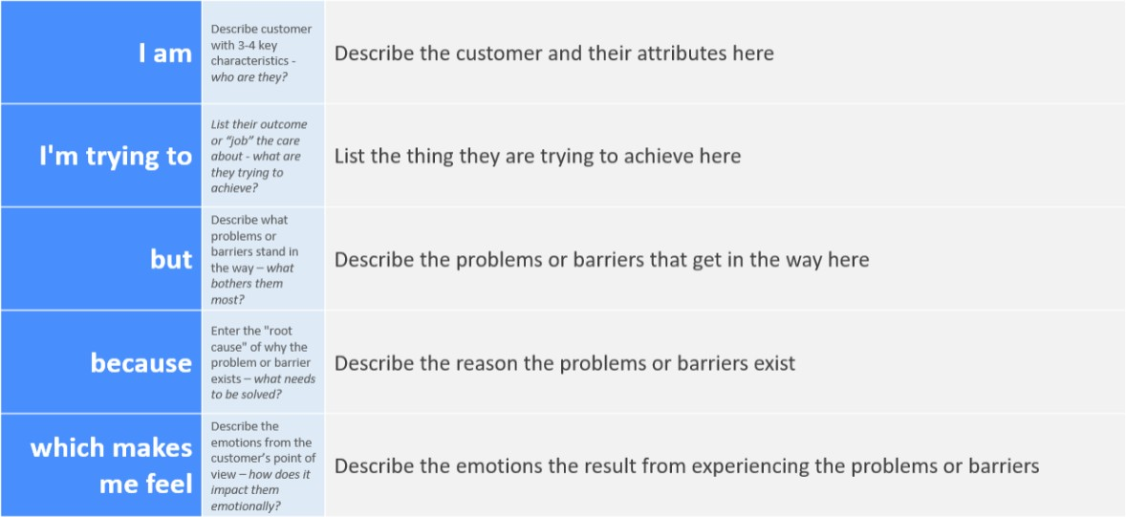

# Example:

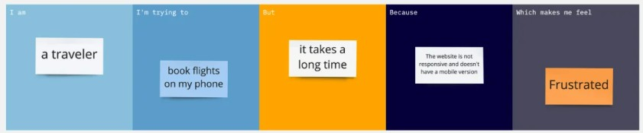

|  |  |  |  |  |  |
| --- | --- | --- | --- | --- | --- |
| **Problem**  **Statement (PS)** | **I am**  **(Customer)** | **I’m trying to** | **But** | **Because** | **Which makes me feel** |

|  |  |  |  |  |  |
| --- | --- | --- | --- | --- | --- |
| PS-1 | The  Metropolitan city  people | Solve the problem  caused due to the waste disposals, irregular monitoring of garbage bin and the overflow of garbage in the bin which causes the diseases | not able to clear wastes on time | of poor actions  taken by the  Management | disturbed |
| PS-2 | The  students in cities | To clean the surrounding | Unable to manage  the effect of  Pollution caused by the E-wastes | the  management actions are poor | frustrated |